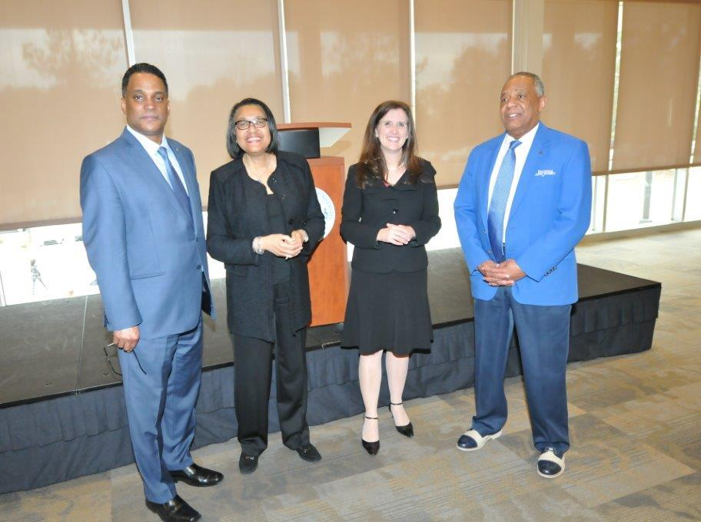

FAYETTEVILLE STATE RECEIVES GRANT TO SUPPORT STUDENTS
WITH LEARNING DIFFERENCES

FAYETTEVILLE, N.C. (February 12, 2015) – Students who learn differently will have access to an array of academic supports through a new program at Fayetteville State University (FSU) called Bronco STAR (Supporting Transition, Access and Retention). The program has been made possible through a three-year $1 million grant from the N.C. GlaxoSmithKline Foundation.
Bronco STAR will build on programs that already have earned Fayetteville State recognition as an Exemplar Institute for Access and Success by the Washington-DC-based Institute for Higher Education Policy. Through the Bronco STAR initiative, Fayetteville State will join the College STAR program which already has been implemented at East Carolina University, the University of North Carolina Greensboro, and Appalachian State University. All College STAR programs are focused on providing support for students who, in the past, have slipped through the cracks of the education system even though they are capable of college success.
Each participating UNC campus has designed a model that weaves together direct student-support targeted to specific populations as well as instructional support for faculty members interested in teaching methods that can facilitate student achievement. While each campus model is unique, common elements of the programs thread throughout all participating campuses to maximize opportunities for collaboration and shared learning. The overall program is funded by the Oak Foundation of Geneva, Switzerland.
“Fayetteville State will expand the College STAR network to include an historically Black institution, one of four in the UNC system,” said Marilyn Foote-Hudson, Executive Director of the N.C. GlaxoSmithKline Foundation. “Fayetteville State serves military-affiliated students, and perhaps most importantly, has a focus on identifying learning differences in a broad population that is diverse in terms of age, ethnicity and previous experience with college, many of who may not be officially or legally labeled for a learning disability.”
Dr. James A. Anderson, Chancellor at Fayetteville State, said the funding will assist the university in addressing one of its key priorities—retention and graduation. “With Bronco STAR we are pleased to expand FSU’s institutional capacity and leadership to students who learn differently and whose talent, skills, and unique perspectives are critically needed in our state and our world,” he said.
Dr. D. Jason DeSousa, Assistant Vice Chancellor for Student Retention at Fayetteville State, will serve as Project Director for Bronco STAR. Applications for the program will be open to all students. Potential participants will be identified from two primary populations: traditional college students who are in their late teens and recent high school graduates and transfer students who often are older, more experienced and have significant life experience.
“Transfer students may bring a broad range of adaptive skills to college that have worked more or less well in their lives so far,” DeSousa said, “but these skills may break down in the college environment because of differences in the way they learn.” Student support available through Bronco STAR is expected to include dedicated study space, tutoring services, success coaches, psychosocial services, high impact practices, and personalized academic success plans. Assistive technology is another essential feature of Bronco STAR.
The faculty component of Bronco STAR will be designed to infuse the principles of Universal Design for Learning (UDL) throughout a variety of educational environments. Fayetteville State will be providing a range of professional development opportunities for faculty and staff and supporting learning communities focused on the implementation and evaluation of instructional approaches that align with UDL.
Founded in 1867, FSU is the second-oldest public institution in North Carolina. It offers nearly 60 degrees in the arts, sciences, business, and education at the undergraduate, graduate, and doctoral levels. It serves a student body of nearly 6,000 students and has a faculty and staff of approximately 800.
The North Carolina GlaxoSmithKline Foundation is an independent self-funding 501(c)3 nonprofit organization supporting activities that help meet the educational and health needs of today's society and future generations. Since its creation in 1986, the Foundation has granted over $61 million to support North Carolina projects and programs that emphasize the understanding and application of health, science and education at all academic and professional levels. Visit the North Carolina GlaxoSmithKline Foundation at NCGSKFoundation.org and follow it @ncgskfound.

For more information, call (910) 672-1474.

