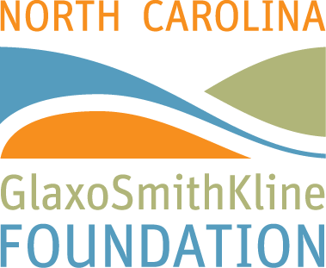

Apply for a North Carolina GlaxoSmithKline Foundation’s
Ribbon of Hope Grant

May 15, 2015 - The North Carolina GlaxoSmithKline Foundation is seeking project proposals for its Ribbon of Hope grant program, which supports activities that advance science, health, and education in local communities across the state of North Carolina.

Twice each year, the Foundation awards one-time grants of $25,000 to North Carolina community-based nonprofit 501(c)(3) organizations. Successful proposals typically receive funds to develop a new initiative or to expand and/or enhance an existing project. In addition, grantees will benefit from technical assistance provided by the North Carolina Center for Nonprofits.

Applicants should note that the Request for Proposals (RFP) for the Ribbon of Hope program was recently revised. The revisions include:
- a reorganized proposal outline
- detailed guidance on the information grant proposals should include
- updated templates for project budget plans and communication plans
- new resources for guidance on grant writing

Proposed projects should be tightly aligned with the mission of the Ribbon of Hope grant program to advance science, health, and education in local communities across the state of North Carolina; address critical community needs that have been identified through a comprehensive needs assessment; provide clear and concise descriptions of project activities; and demonstrate sustainability after grant funds are expended.

Project proposals are accepted and awarded on an ongoing basis:
- Proposals submitted by October 1 will be reviewed and notification of award(s) will be made the following April.
- Proposals submitted by April 1 will be reviewed and notification of award(s) will be made the following October.

Proposals (one print copy and one electronic copy on a USB flash/thumb drive) should be submitted to the Foundation’s administrative partner, McREL International:
McREL International
Attn: Jesse Rainey – Ribbon of Hope
4601 DTC Boulevard, Suite 500
Denver, CO 80237

For more information about the Ribbon of Hope grant program, and to view the complete Request for Proposals, visit http://www2.mcrel.org/NCGSKFRibbonOfHope/index.asp# For more information about the North Carolina GlaxoSmithKline Foundation, please visit http://www.ncgskfoundation.org/index.html

###

